Lab 3
Introduction to Concurrency
Task 1:
1. How many threads are running?
• Three threads are created (t1, t2, t3) plus the main thread.
• Total threads = 4

2. How many tasks are running?
• Each thread runs the run() method, which prints "task one".
• Total tasks = 3 (same task run by three threads)

3. If more tasks are added, what will be the impact on number of threads?
• Each new task creates a new thread when start() is called.
• More tasks → More threads

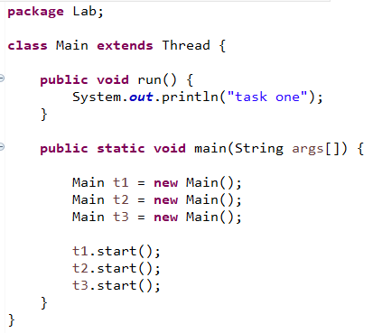
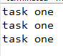
Output:

Task 2:
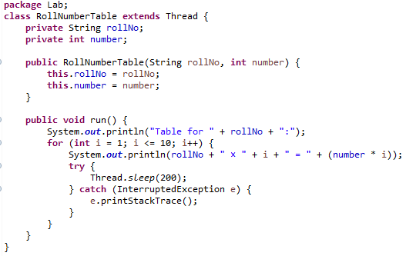
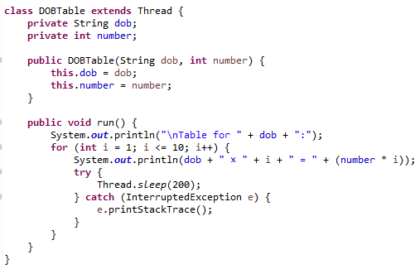
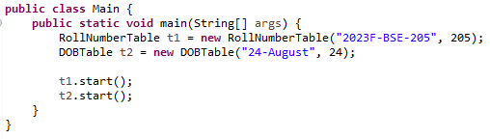
Output:
